**Exception Handling – 2**

**Python Assignment**

**13th Feb 2023**

Q1. Explain why we have to use the Exception class while creating a Custom Exception.

Sol. Use custom exceptions in your projects. Leave built-in exceptions to typical situations in which they are raised, and raise custom ones to inform what went wrong in relation to the application, not the code itself.

**Q2. Write a python program to print Python Exception Hierarchy.**

**Sol.**

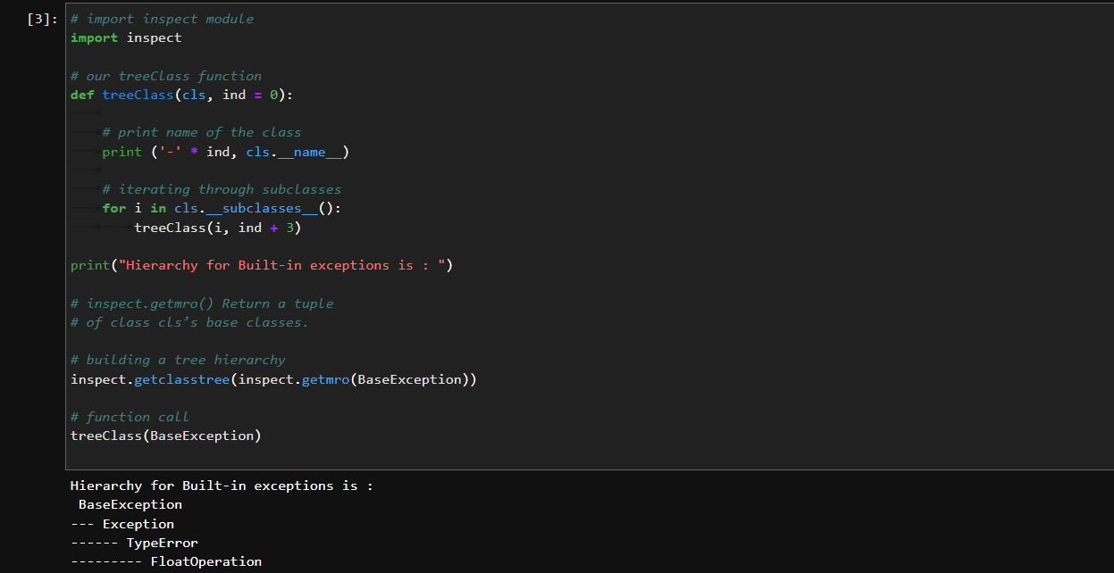

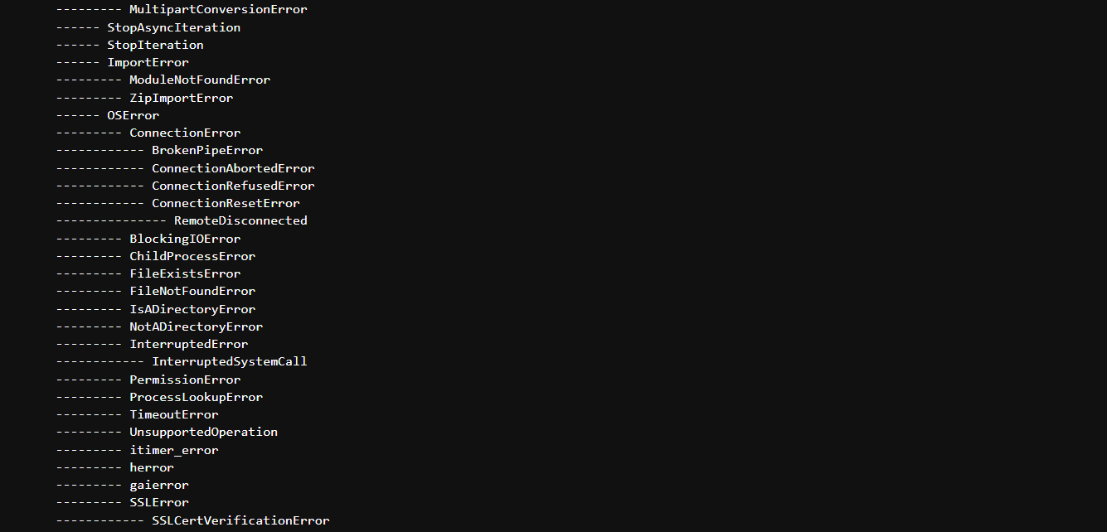

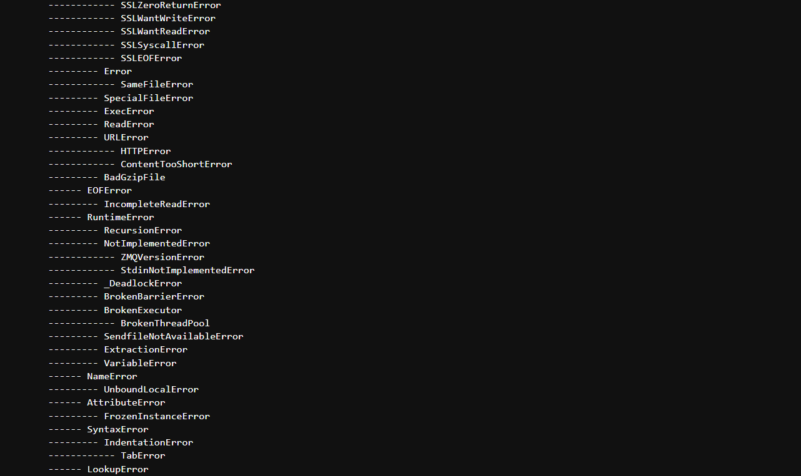

And so on..

**Q3. What errors are defined in the ArithmeticError class? Explain any two with an example.**

**Sol.** The arithmetic error occurs when an error is encountered during numeric calculations in Python. This includes ZeroDivisionError and FloatingPointError. In addition, zero division error is raised when you divide a numeric value by zero.

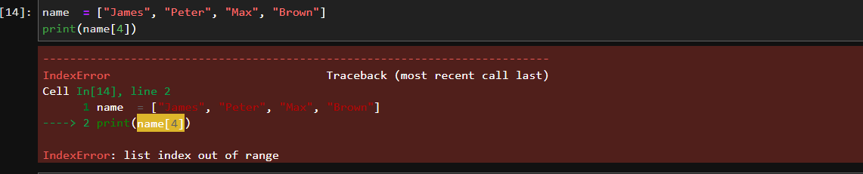

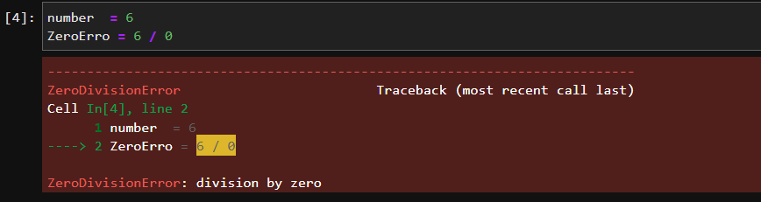

**Q4. Why LookupError class is used? Explain with an example KeyError and IndexError.**

**Sol.** LookupError Exception is the Base class for errors raised when something can’t be found. The base class for the exceptions that are raised when a key or index used on a mapping or sequence is invalid: IndexError, KeyError.

An IndexError is raised when a sequence reference is out of range

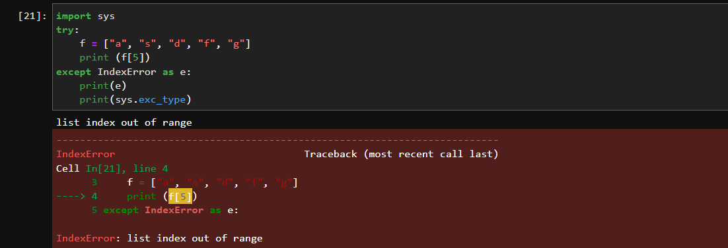

**Q5. Explain ImportError. What is ModuleNotFoundError?**

**Sol.**  ImportError occurs when the Python program tries to import module which does not exist in the private table. This exception can be avoided using exception handling using try and except blocks. We also saw examples of how the ImportError occurs and how it is handled.

When we try to import a module in a Python file, Python tries to resolve this module in several ways. Sometimes, Python throws the **ModuleNotFoundError** afterward. As the name implies, this error occurs when you're trying to access or use a module that cannot be found. In the case of the title, the "module named **Python**" cannot be found. Python here can be any module.

**Q6. List down some best practices for exception handling in python.**

**Sol.**

